Winter Internship 2023-2024
(12th December 2023 to 15th January 2024)

“E-Commerce Website Catalog”

By,

Deeptanshu Lal Roll No. 22CE1285

Shaunak Kundu Roll No. 2CE1161

Supervisor
Mrs. Saguna Ingle



Department of Computer Engineering Ramrao Adik Institute of Technology,
Sector 7, Nerul, Navi Mumbai
(Under the ambit of D. Y. Patil Deemed to be University)
January 2024

Ramrao Adik Institute of Technology
(Under the ambit of D. Y. Patil Deemed to be University)
Dr. D. Y. Patil Vidyanagar, Sector 7, Nerul, Navi Mumbai 400 706.

Certificate

This is to certify that, the Winter Internship Project entitled

“E-Commerce Product Catalog”

is a bona fide work done by
Deeptanshu Lal Roll No. 22CE1285 Shaunak Kundu Roll No. 22CE1161
and is submitted in the partial fulfillment of the requirement for the
Winter Internship 23-24.
to the

Ramrao Adik Institute of Technology,
D. Y. Patil Deemed to be University.

Supervisor
(Mrs. Saguna Ingle)



Approval Sheet

This Winter Internship entitled “E-Commerce Product Catalog” by Deeptanshu Lal Roll No. 22CE1285, Shaunak Kundu Roll No.22CE1161 is approved in the partial fulfillment of the requirement for the Winter Internship 2023-2024 in the department of Computer Engineering.

Examiners

1………………………………………
(Internal Examiner Name & Sign)

2…………………………………………
(External Examiner name & Sign)

Date:

Place:

ii

Abstract
In the digital era, e-commerce platforms have revolutionized the way businesses present and market their products to consumers worldwide. The e-commerce catalog serves as a pivotal tool in this landscape, providing a structured, visual, and interactive representation of available products and services. This abstract delves into the significance, structure, and functionalities of an e-commerce catalog.

The primary objective of an e-commerce catalog is to offer users a seamless and intuitive browsing experience, enabling them to explore products, gather information, and make informed purchase decisions. It amalgamates product details such as images, descriptions, specifications, pricing, and reviews into a cohesive and accessible format. The catalog's design emphasizes user-friendliness, ensuring that customers can effortlessly navigate through categories, filter results, and access relevant information.

Contents

- Introduction
  - Overview
  - Motivation
  - Problem Statement and Objectives
- Literature Survey
  - Survey of Existing System
  - Limitations of Existing System
- Proposed System
  - Problem Statement
  - Proposed Methodology / Techniques
  - System Design
  - Details of Hardware and Software Requirements

- Results and Discussion
  - Implementation Details

  - Project Outcomes

- Conclusion and Future Work

References

Appendix -I
Participation Details (Project competition/Hackathon/Paper Publication…)

Appendix -II
Weekly progress report.

Chapter 1 Introduction
In the rapidly evolving digital marketplace, the e-commerce catalog stands as a foundational element that shapes the online shopping experience for consumers worldwide. Serving as a virtual storefront, an e-commerce catalog presents a curated collection of products and services in an organized, accessible, and visually appealing manner. This introduction delves into the essence, evolution, and significance of e- commerce catalogs in the contemporary retail landscape.

An e-commerce catalogs play a pivotal role in shaping consumer perceptions, influencing purchase decisions, and driving business growth. By showcasing products in a visually appealing and informative manner, catalogs foster trust, credibility, and brand loyalty among consumers. Moreover, they enable businesses to showcase their product assortment, highlight unique selling propositions, and differentiate themselves in a competitive marketplace.

Motivation:
The primary motivation behind an e-commerce catalog is to provide a centralized, organized, and visually appealing platform that enables consumers to explore, evaluate, and purchase products or services seamlessly. Essentially, the e-commerce catalog aims to enhance the shopping experience by presenting a curated collection of products with detailed information, compelling visuals, and user-friendly navigation.

Our project facilitates easier product discovery, comparison, and decision-making for consumers, ultimately driving sales, customer satisfaction, and loyalty for businesses.

Objectives:
The primary objectives of an e-commerce catalog include:
Facilitating Product Discovery: To provide users with a centralized platform where they can easily discover, browse, and explore a comprehensive range of products or services offered by a business.

Enhancing User Experience: To offer a seamless, intuitive, and engaging browsing experience by organizing products systematically, incorporating high-quality visuals, detailed descriptions, and user-friendly navigation features.

Informing Purchase Decisions: To empower consumers with relevant information, specifications, pricing details, reviews, and recommendations that enable them to make informed and confident purchase decisions

Building Brand Identity and Credibility: To communicate the brand's values, identity, and value proposition through consistent branding elements, compelling visuals, and engaging content that resonate with the target audience.

Chapter 2 Literature Survey
User Experience and Design: Studies focusing on the design principles, usability, and user experience of tsuki, examining how layout, visuals, navigation, and interactivity impact user engagement, satisfaction, and conversion rates.

Content Management and Optimization: Literature discussing content strategies, optimization techniques, and best practices for managing product information,
descriptions, images, videos, and other multimedia elements within our website ‘tsuki’ to enhance visibility, discoverability, and conversion rates.

Search and Navigation: Search algorithms, filtering options, faceted navigation, and search engine optimization (SEO) strategies within e-commerce catalogs, exploring how these elements impact search accuracy, relevance, and user satisfaction.

Customer Behavior and Purchase Decision Making: Consumers behavior, decision- making processes, and influencing factors within e-commerce catalogs, analyzing how product presentation, reviews, ratings, social proof, and other elements impact purchase intentions, trust, and loyalty.

Personalization and Recommendation Systems: Research exploring the role of personalization algorithms, machine learning, and data analytics in e-commerce catalogs, assessing their effectiveness in delivering personalized product recommendations, content, and promotions based on user behavior, preferences, and historical data.

Limitation of Existing System

Product Information Accuracy: Maintaining accurate and up-to-date product information is challenging. Prices, stock availability, product descriptions, and images need regular updates, and discrepancies can lead to customer dissatisfaction.

Scalability Issues: As a business grows and adds more products to its catalog, managing and organizing them can become complex. This can affect the performance and user experience of the e-commerce platform.

Search and Navigation Challenges: A vast catalog can make it difficult for customers to find specific products quickly. Without effective search and navigation features, customers may abandon the site.

Product Representation: Representing physical products accurately through digital means is challenging. Customers can't touch or feel products, so providing detailed descriptions, images, and videos becomes crucial. However, conveying all product details effectively can be challenging.

Mobile Responsiveness: As more customers shop using mobile devices, ensuring that the e-commerce catalog is optimized for various screen sizes and devices is crucial.
However, managing a responsive catalog that provides a consistent user experience across devices can be challenging.

Cost of Maintenance: Regularly updating, optimizing, and managing an e-commerce catalog requires resources, including manpower and technology. The ongoing cost of maintaining a comprehensive and user-friendly catalog can be significant for businesses.

Chapter 3

Problem Statement

The e-commerce catalog struggles with user experience, data accuracy, scalability, integration, personalization, security, and differentiation, impacting customer engagement, trust, and business growth

System Design

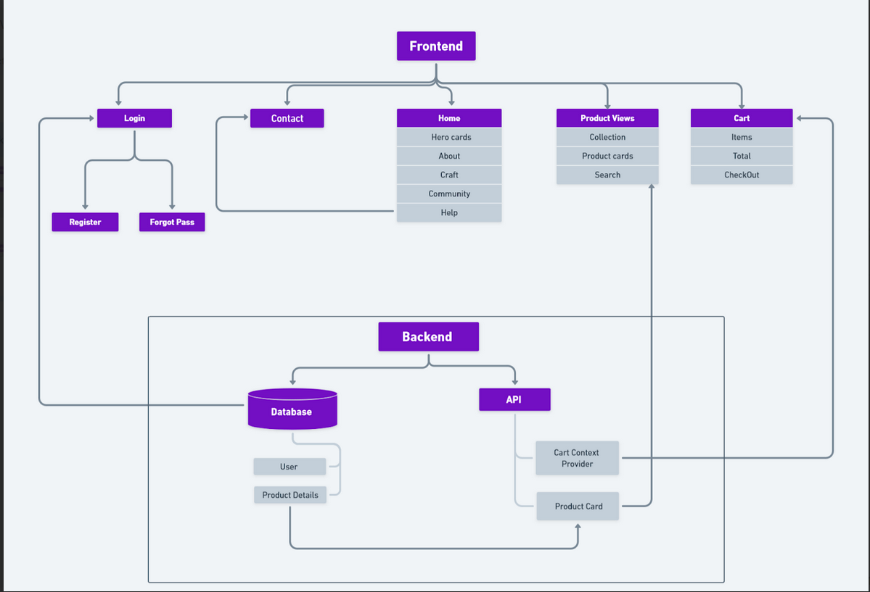

Detailed Product Information: Each product is listed in comprehensive details such as product description, specifications, size, color options, materials used, care instructions, and other relevant information.

High-Quality Images: Clear and high-resolution product images from multiple angles help customers visualize the product and make informed purchase decisions

Product Reviews and Ratings: Including customer reviews and ratings for products can build trust and credibility. It helps potential buyers make purchase decisions based on the experiences of previous customers.

Search Button: A search button is implemented which helps to narrow down your preferences.
Real-Time Inventory Management: Displaying real-time stock availability prevents customers from ordering out-of-stock items and helps manage customer expectations regarding delivery times.

Easy Navigation and User-Friendly Interface: Organize products into logical categories and subcategories with intuitive navigation menus, ensuring that customers can easily browse and explore the catalog.

Add to Cart: By clicking this button, users can place items into a virtual shopping cart, enabling them to continue browsing or proceed to check out later

Customer care and services: This will for building trust, ensuring satisfaction and fostering loyalty among the online shoppers.

Details of Hardware and Software Requirements

For Software:

    - HTML (Hyper Text Markup Language):HTML is the standard markup language used to create and structure content on web pages. It utilizes tags to define elements such as headings, paragraphs, links, and images, enabling browsers to interpret and display content correctly. HTML forms the foundation of web development, providing structure and semantics for content presentation.

    - CSS (Cascading Style Sheets): CSS is a stylesheet language used to define the visual presentation and layout of HTML elements on web pages. It controls aspects like colors, fonts, spacing, and responsive design, enhancing the aesthetic appeal and user experience. By separating content from presentation, CSS simplifies web development, enabling consistent styling across multiple pages or devices.

    - React JS: React.js is a popular JavaScript library developed by Facebook for building user interfaces, emphasizing component-based architecture. It enables developers to create interactive and dynamic web applications with efficient data binding and state management.

For Hardware:

Operating System:
- Windows: 7 (32/64 bit) or higher, preferably 10 or 11
- macOS: 10.10 or higher
- Linux: Ubuntu 16 or higher
Hardware:
- Processor: A modern dual-core or better processor is recommended.
- RAM: 4GB of RAM is the minimum, but 8GB or more is ideal for a smoother experience, especially with larger projects.
- Storage: At least 10GB of available storage space is needed for React itself and its associated tools and dependencies.
Other Requirements:
- Web browser: A modern web browser like Chrome, Firefox, Edge, or Safari is essential for viewing and testing React applications.
- Node.js and npm: React relies on Node.js and its package manager, npm, for managing dependencies and running build scripts. Ensure you have both installed on your system. You can download them from the official Node.js website: https://nodejs.org/
- Code editor: A code editor or IDE (Integrated Development Environment) is necessary for writing and editing React code. Popular choices include Visual Studio Code, Atom, Sublime Text, and WebStorm.
Recommended Specifications for Optimal Performance:
- Processor: Intel Core i5 or equivalent
- RAM: 8GB or more
- Storage: SSD for faster loading times
- Display: Full HD (1920x1080) resolution or higher

Chapter 4

Results and Discussion
Tsuki serves as an online platform for businesses to buy products. It facilitates transactions through secure payment gateways, enabling users to browse, select, and purchase items conveniently. Features like product catalogs, search functionality, customer reviews, and personalized recommendations enhance user experience and drive sales. Effective inventory management ensures accurate product availability information and timely order fulfillment. Integration with logistics and shipping partners streamlines delivery processes, ensuring prompt and reliable product delivery.

Tsuki has revolutionized the way businesses operate, enabling online transactions, global reach, and seamless customer experiences. Its growth is fueled by technological advancements, changing consumer preferences, and the convenience of shopping anytime, anywhere. However, challenges such as security concerns, competition, logistics, and maintaining customer trust require strategic planning and adaptation.

This section provides an overview of the project outcomes, including screenshots and key results derived from the implementation of the e-commerce.

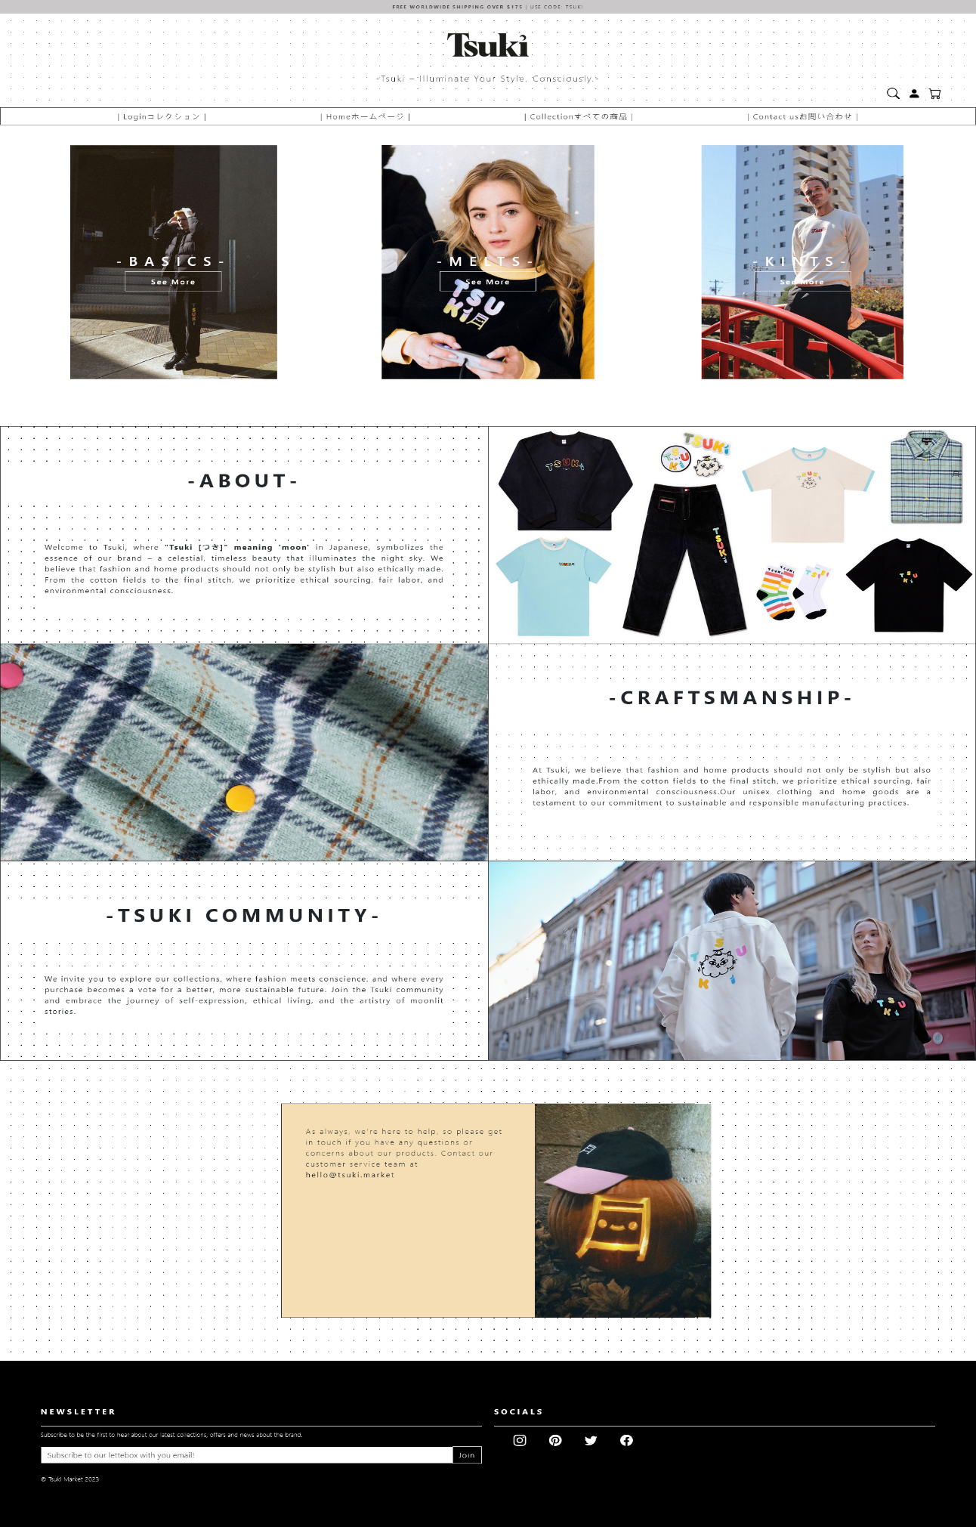

Fig-1.1 Home Page

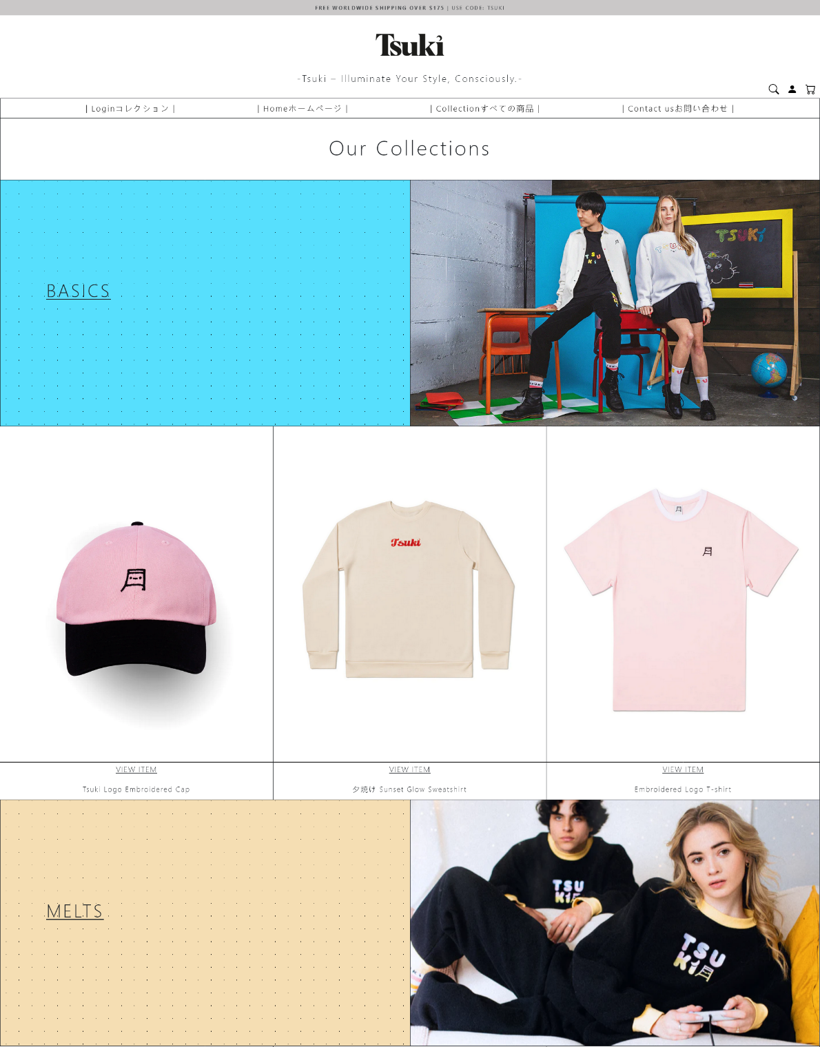

Fig-1.2 Collection Page

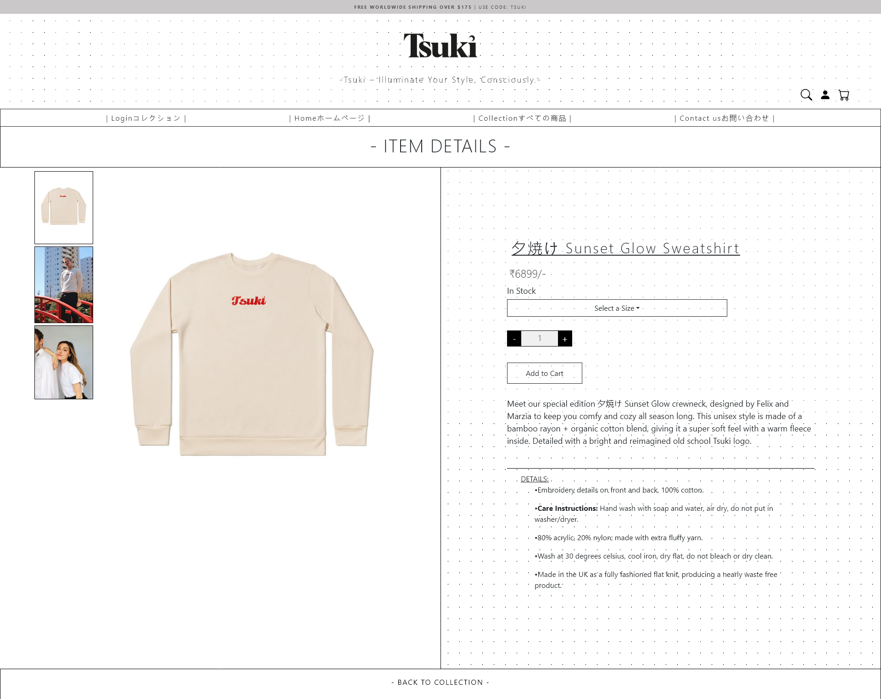

Fig-1.3 Product page

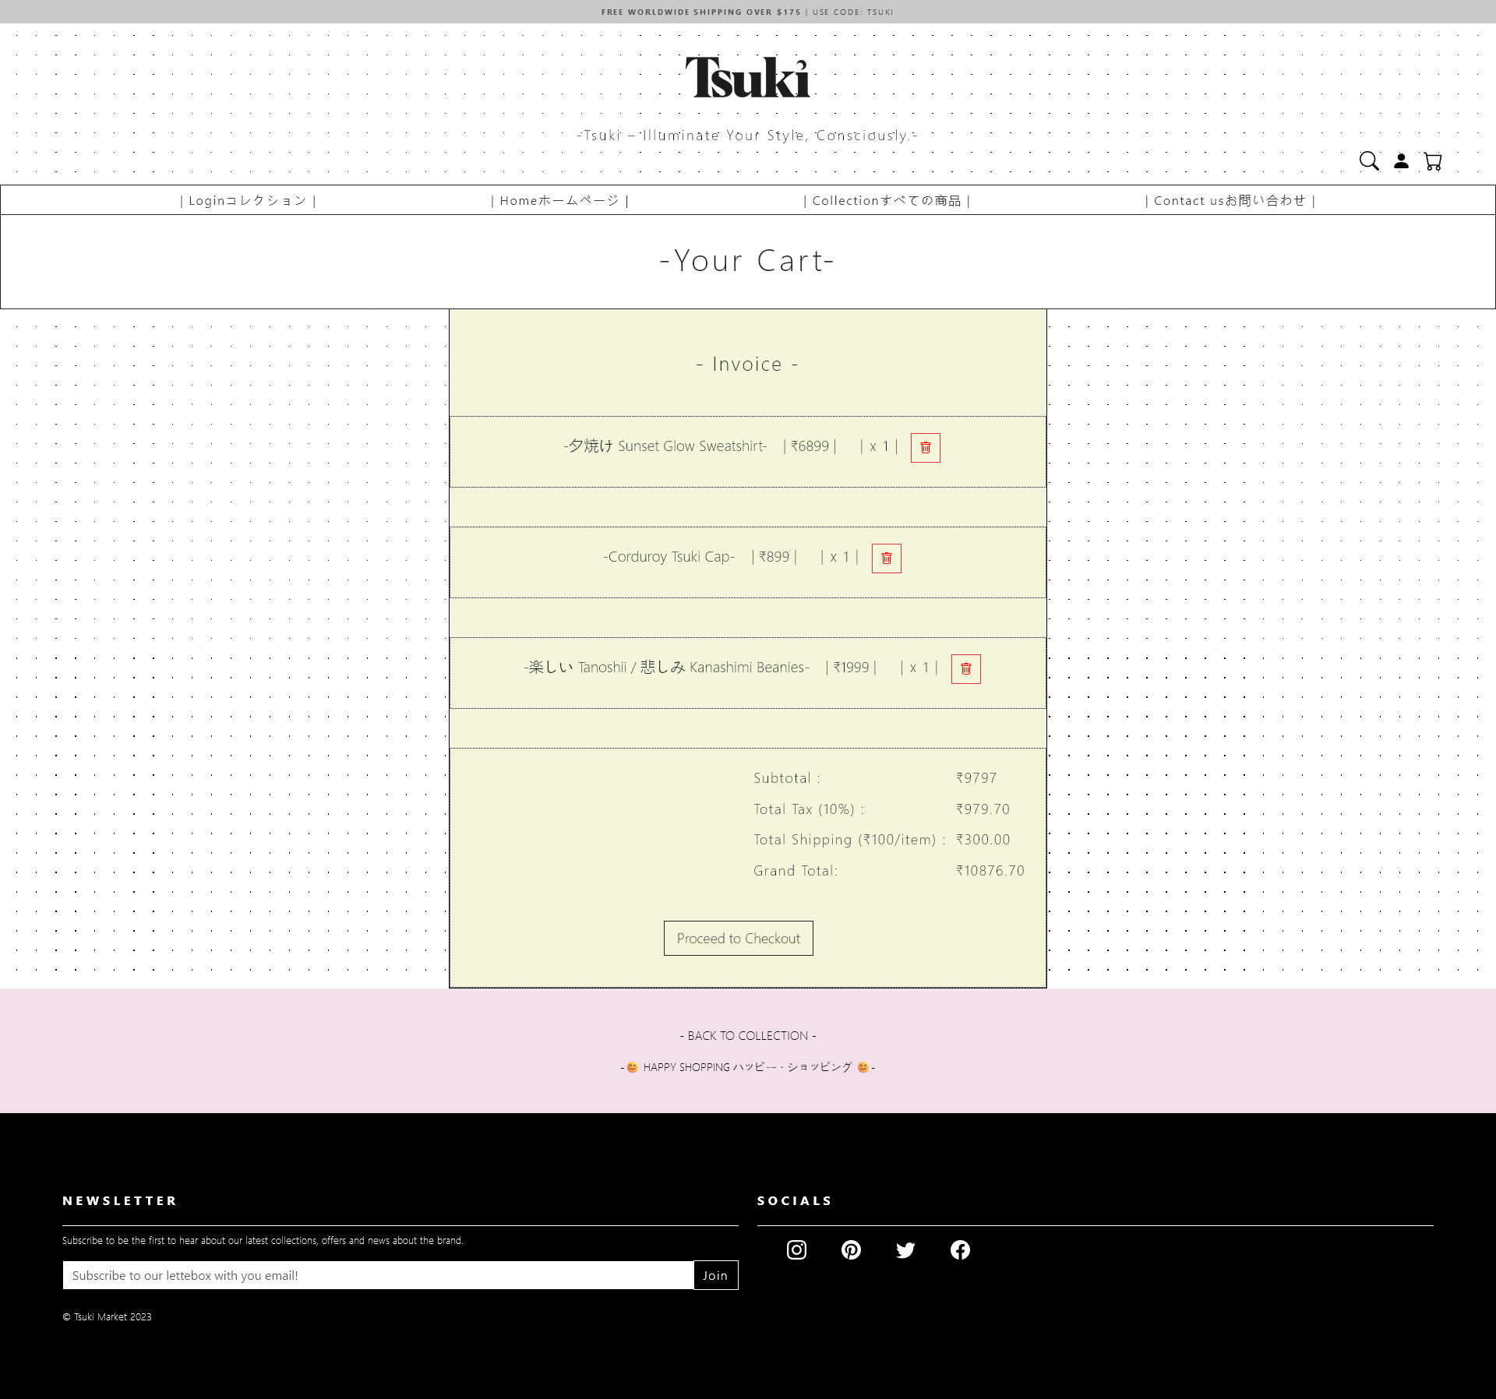

Fig-1.4 Cart page

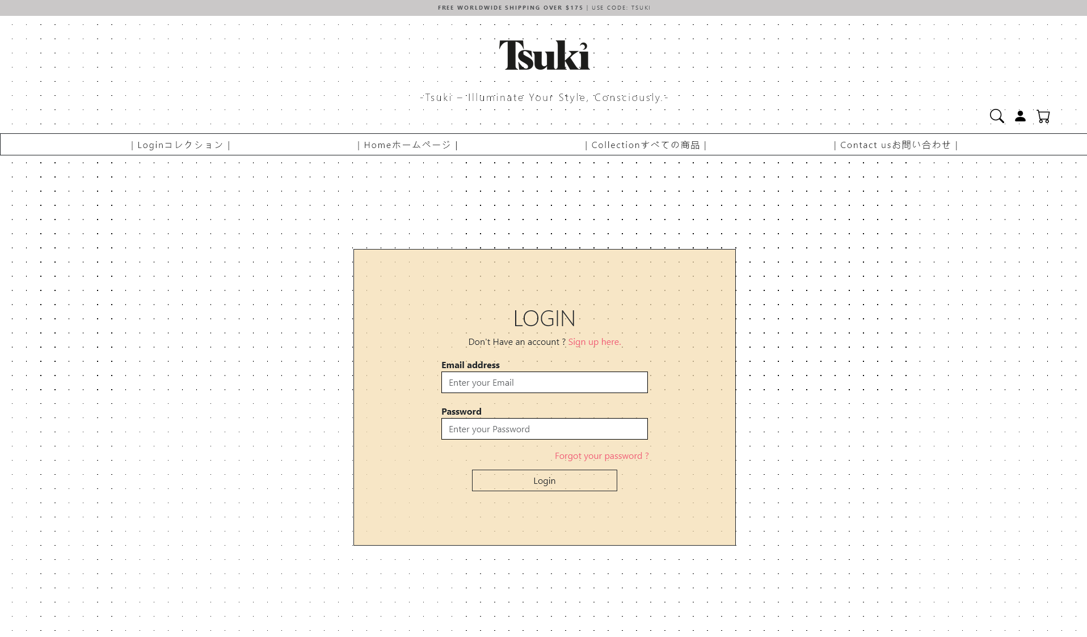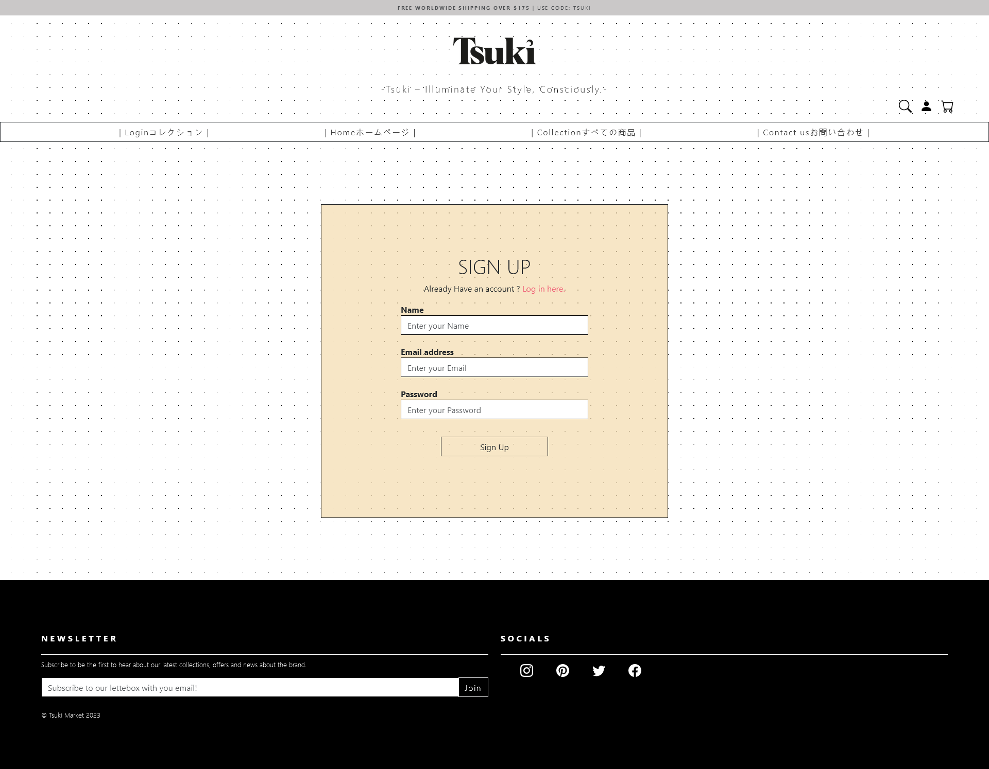

Fig-1.5/1.6 Login /Sign -Up Page
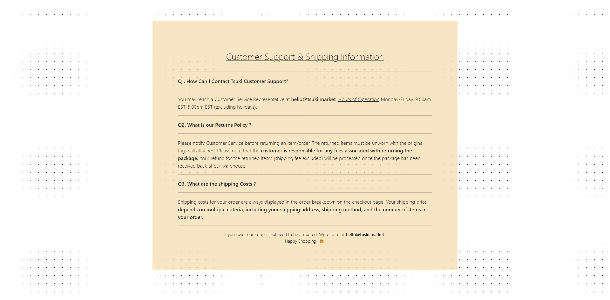

Fig-1.7 Contact page

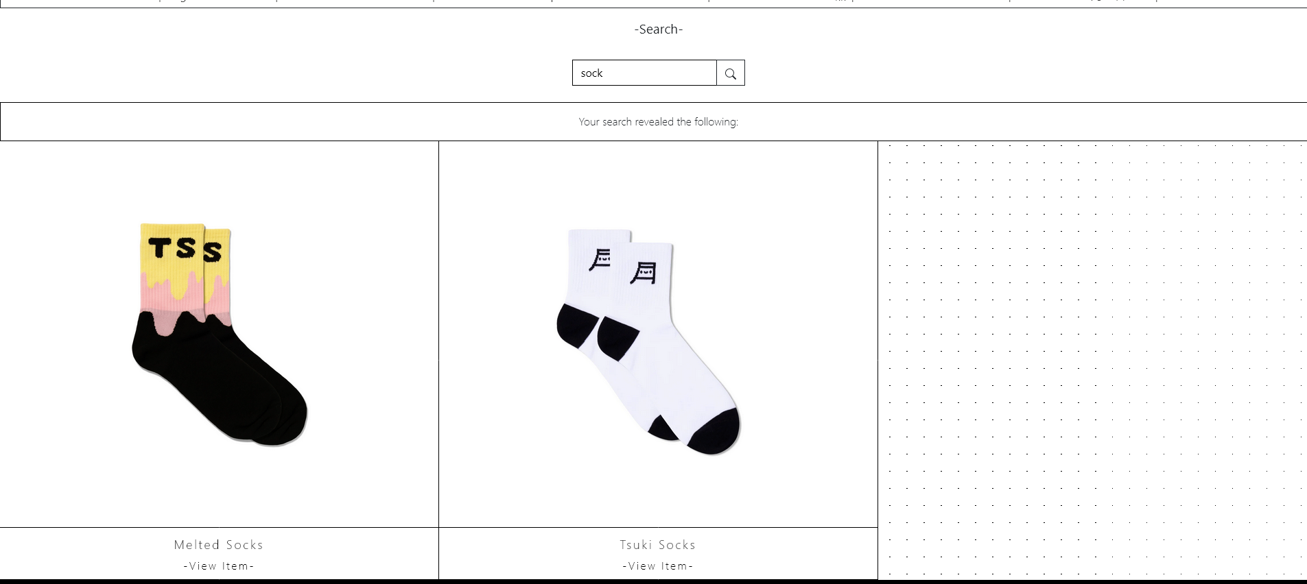

Fig-1.8 Search Page





Fig-1.8 Header/Footer

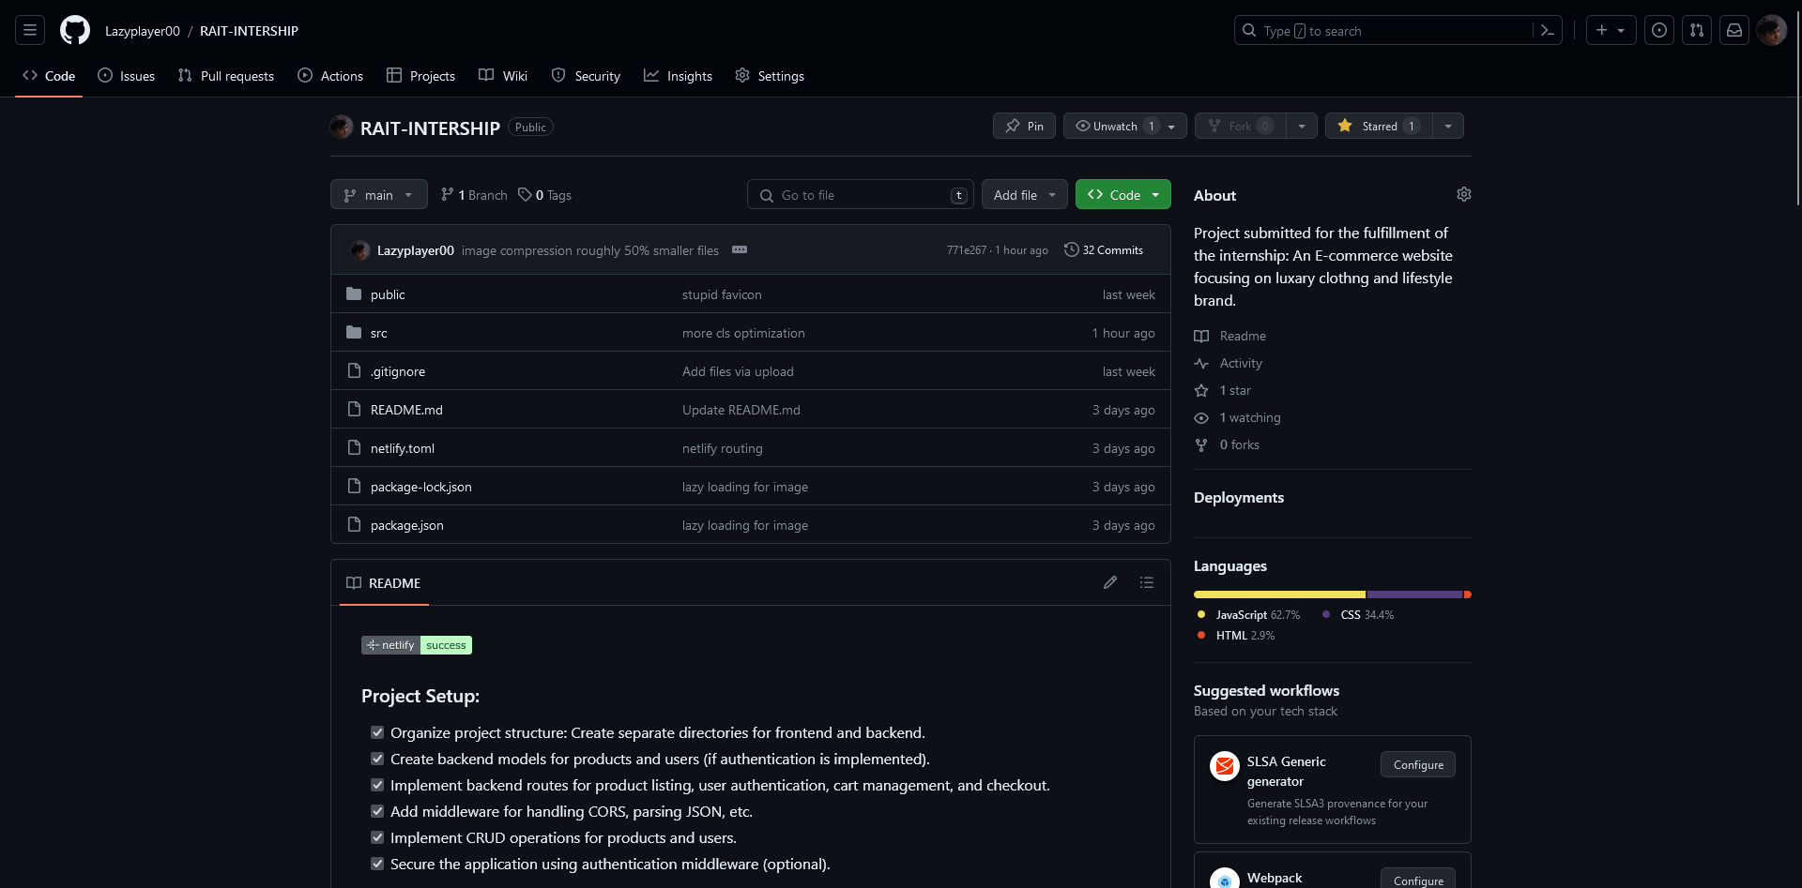

Fig-2.1 GitHub page

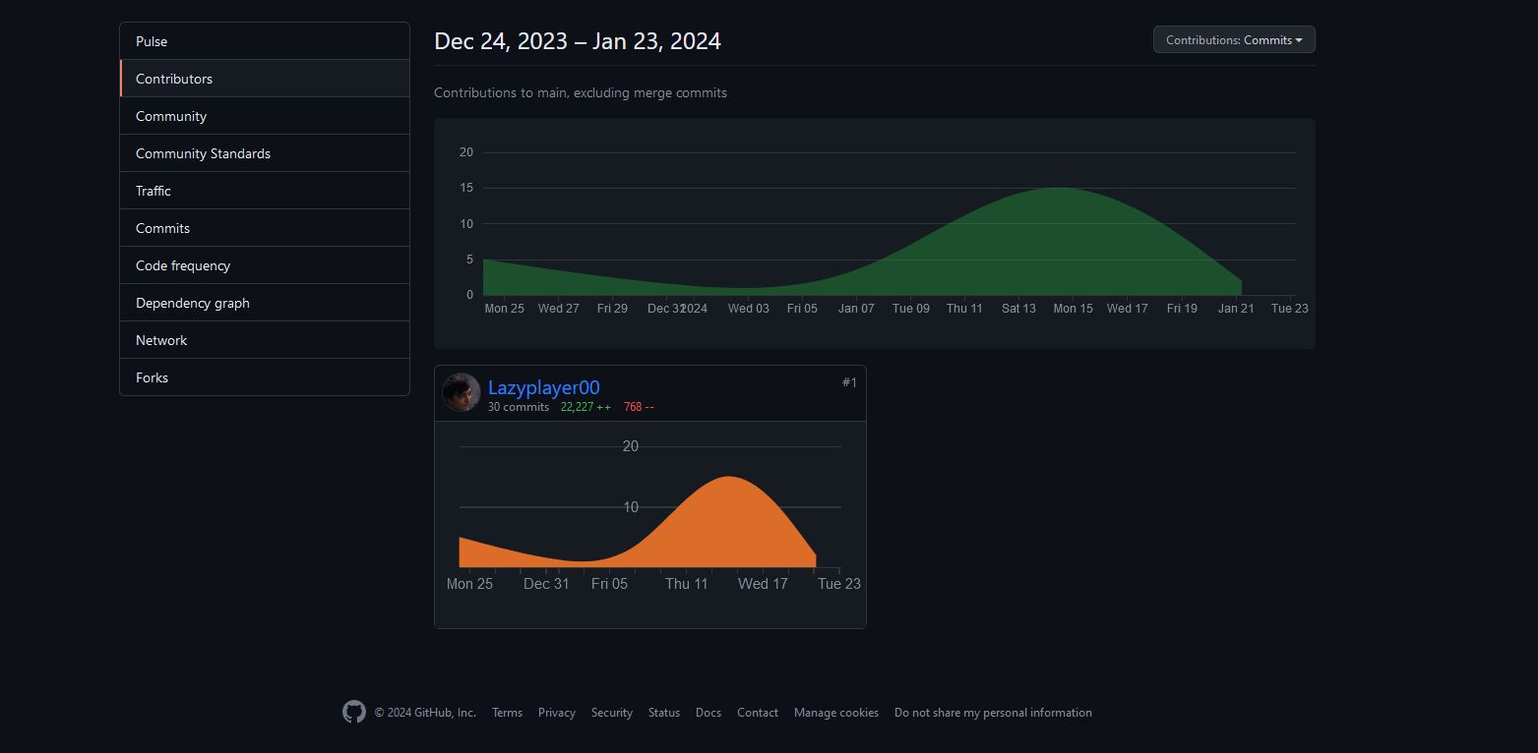

Fig-2.1 GitHub Contribution page

Chapter 5

Conclusion and Future work:

"Tsuki, an imaginative e-commerce platform, embodies the essence of innovation and customer-centric design in the digital marketplace. Through its user-friendly interface, diverse product catalog, and seamless shopping experience, Tsuki has successfully bridged the gap between consumer expectations and online retail excellence. Emphasizing quality, trust, and personalized interactions, Tsuki continues to elevate the e-commerce landscape, setting benchmarks for user experience, product diversity, and business growth.

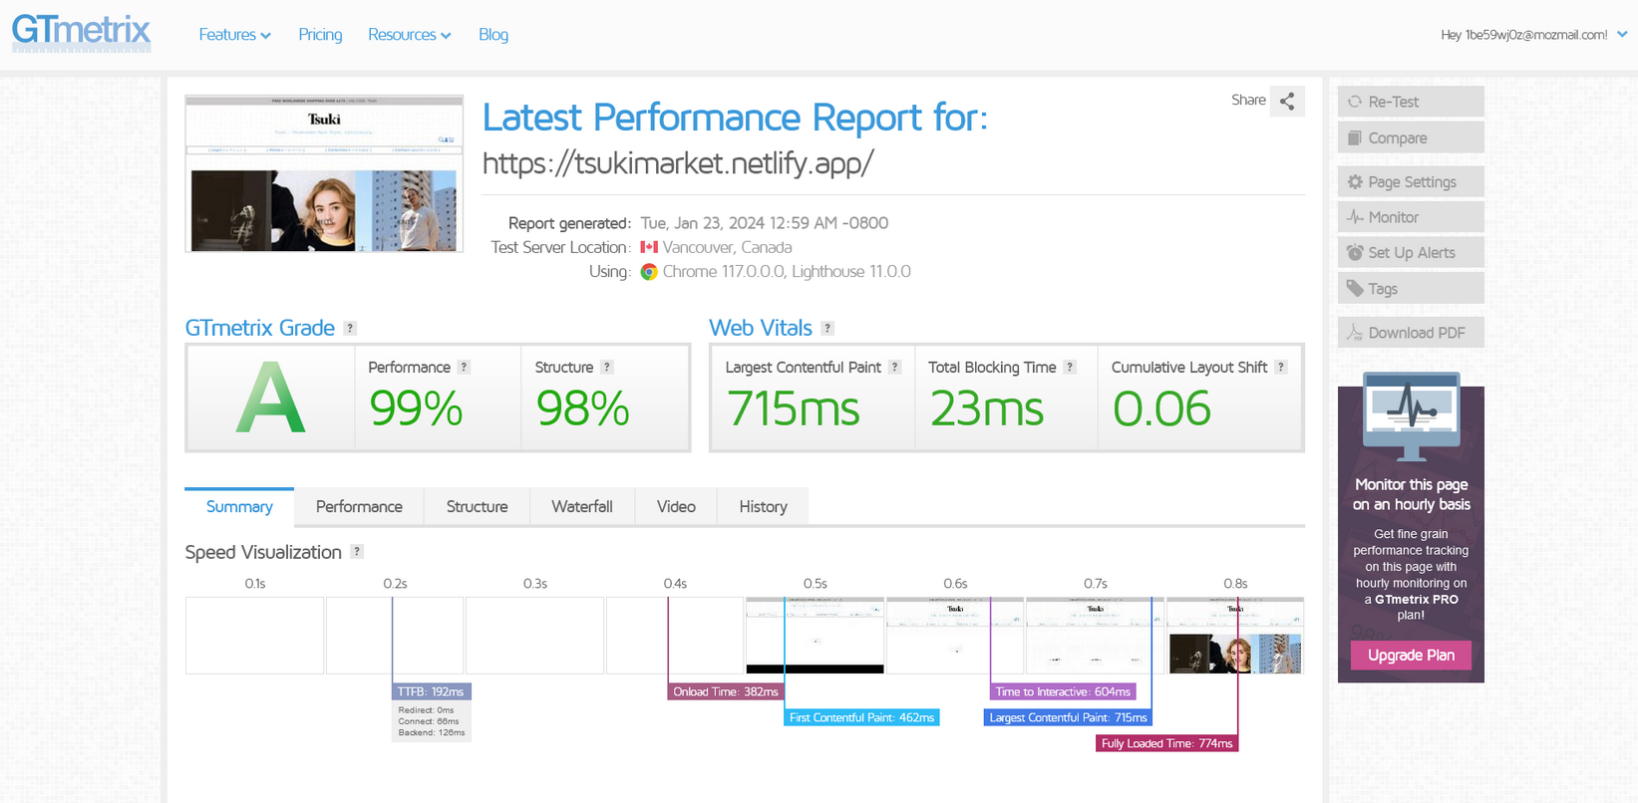
Fig-3.1 GTmetrix page
(indication of performance of the website)

References
- Books:

  - "E-Commerce 2020: Business, Technology, Society" by Kenneth C. Laudon and Carol Guercio Traver.
  - "The Everything Store: Jeff Bezos and the Age of Amazon" by Brad Stone.
  - "E-Commerce Essentials" by Kenneth C. Laudon and Carol Guercio Traver.

- Research Reports & Journals:

- Reports from leading market research firms such as Gartner, Forrester, and Statista on e- commerce trends, statistics, and forecasts.

- Academic journals like the "Journal of Electronic Commerce Research" provide scholarly articles on e-commerce theories, practices, and innovations.

- Websites & Online Platforms:

- Websites of prominent e-commerce companies like Amazon, Alibaba, eBay, and Shopify for insights into their business models, strategies, and best practices.

- Courses & Online Learning Platforms:

- E-commerce courses offered by universities, online learning platforms like Coursera, edX, and Udemy provide structured learning materials, lectures, and case studies on e- commerce topics.

Appendix -I

Participation Details
- Deeptanshu Lal – None
- Shaunak Kundru - None

Appendix -II
(Snapshot of weekly progress report signed by students and guide.)

